
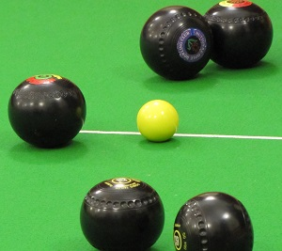
Westgate Carpet Bowls Club

As from 13th April we will be meeting on a Monday evening from 7.00 pm. - 8.30 pm.

We are always keen to welcome new members and players of all abilities are welcome to join us.
Come along and give it a try!
Sessions take place upstairs in the Village Hall.

For further information or to answer any queries you may have, contact Peter Nattrass at psnattrass@gmail.com



